ACSL
American Computer Science League
2013-2014

Contest #4

Senior Division

- Data Structures
1.
What is the external path length of the binary search tree for:

CENTENNIALSTATE

2. Data Structures
2.

What would the next popped element be in the following queue?
PUSH(B), PUSH(L), PUSH(A), POP(X), PUSH(C), PUSH(K), POP(X), POP(X), PUSH(C), POP(X), POP(X), PUSH(A), PUSH(N), POP(X), PUSH(Y), POP(X), POP(X), PUSH(O), PUSH(N), POP(X)

3. Digital Electronics
Which ordered triple(s)
make the following
circuit true?

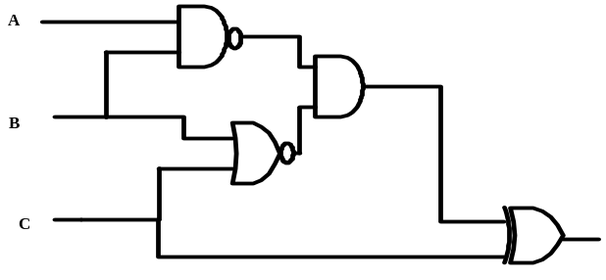
3.

4. Digital Electronics Simplify the Boolean expression represented
4.
by the digital circuit.
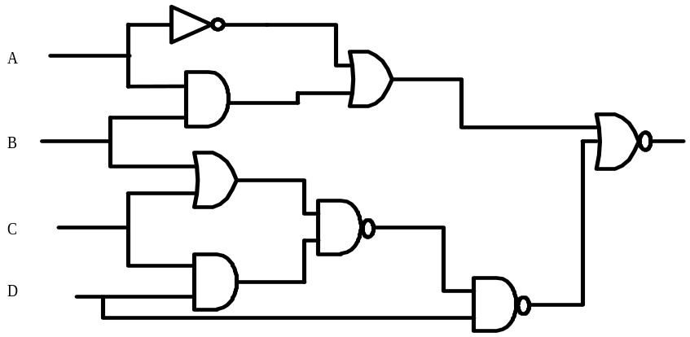
- LISP
Evaluate

( CAR ( CAR ( REVERSE ‘( ( A B ) C ( ( D E ) F ) ) ) ) )

5.

